**UNIT 4:**

1.Explain different substitution techniques with example.

Ans:

A substitution technique is one in which the letters of plaintext are replaced by other letters or by numbers or symbols.If the plaintext is viewed as a sequence of bits, then substitution involves replacing plaintext bit patterns with ciphertext bit patterns.

1.Caesar Cipher

The earliest known use of a substitution cipher, and the simplest, was by Julius Caesar. The Caesar cipher involves replacing each letter of the alphabet with the letter standing three places further down the alphabet. For example,

plain: meet me after the toga party

cipher: PHHW PH DIWHU WKH WRJD SDUWB

Note that the alphabet is wrapped around, so that the letter following Z is A. We can define the transformation by listing all possibilities, as follows: plain: a b c d e f g h i j k l m n o p q r s t u v w x y z

cipher: D E F G H I J K L M N O P Q R S T U V W X Y Z A B C

2.Monoalphabetic Ciphers:

With only 25 possible keys, the Caesar cipher is far from secure. A dramatic increase in the key space can be achieved by allowing an arbitrary substitution.

In caesar substitution we have seen:

plain: a b c d e f g h i j k l m n o p q r s t u v w x y z

cipher: D E F G H I J K L M N O P Q R S T U V W X Y Z A B C

If, instead, the "cipher" line can be any permutation of the 26 alphabetic characters, then there are 26! or greater than 4 x 1026 possible keys. This is 10 orders of magnitude greater than the key space for DES and would seem to eliminate brute-force techniques for cryptanalysis. Such an approach is referred to as a monoalphabetic substitution cipher, because a single cipher alphabet (mapping from plain alphabet to cipher alphabet) is used per message.

There is, however, another line of attack. If the cryptanalyst knows the nature of the plaintext (e.g.,noncompressed English text), then the analyst can exploit the regularities of the language. To see how such a cryptanalysis might proceed, we give a partial example here

UZQSOVUOHXMOPVGPOZPEVSGZWSZOPFPESXUDBMETSXAIZ

VUEPHZHMDZSHZOWSFPAPPDTSVPQUZWYMXUZUHSX

EPYEPOPDZSZUFPOMBZWPFUPZHMDJUDTMOHMQ

A powerful tool is to look at the frequency of two-letter combinations, known as digrams.The most common such digram is th. In our ciphertext, the most common digram is ZW, which appears three times. So we make the correspondence of Z with t and W with h. Then, by our earlier hypothesis, we can equate P with e. Now notice that the sequence ZWP appears in the ciphertext, and we can translate that sequence as "the." This is the most frequent trigram (three-letter combination) in English, which seems to indicate that we are on the right track.

Next, notice the sequence ZWSZ in the first line. We do not know that these four letters form a complete word, but if they do, it is of the form th_t. If so, S equates with a. So far, then, we have

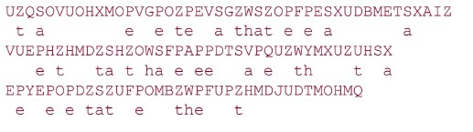

Only four letters have been identified, but already we have quite a bit of the message. Continued analysis of frequencies plus trial and error should easily yield a solution from this point. The complete plaintext, with spaces added between words, follows: it was disclosed yesterday that several informal but direct contacts have been made with political representatives of the viet cong in moscow

3.Playfair Cipher:

The best-known multiple-letter encryption cipher is the Playfair, which treats digrams in the plaintext as single units and translates these units into ciphertext digrams.The Playfair algorithm is based on the use of a 5 x 5 matrix of letters constructed using a keyword.

Here is an example, solved by Lord Peter Wimsey in Dorothy Sayers's Have His Carcase:

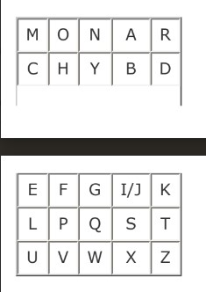

In this case, the keyword is monarchy. The matrix is constructed by filling in the letters of the keyword (minus duplicates) from left to right and from top to bottom, and then filling in the remainder of the matrix with the remaining letters in alphabetic order. The letters I and J count as one letter. Plaintext is encrypted two letters at a time, according to the following rules:

1. Repeating plaintext letters that are in the same pair are separated with a filler letter, such as x, so that balloon would be treated as ba lx lo on.
2. Two plaintext letters that fall in the same row of the matrix are each replaced by the letter to the right, with the first element of the row circularly following the last. For example, ar is encrypted as RM.
3. Two plaintext letters that fall in the same column are each replaced by the letter beneath, with the top element of the column circularly following the last. For example, mu is encrypted as CM.
4. Otherwise, each plaintext letter in a pair is replaced by the letter that lies in its own row and the column occupied by the other plaintext letter. Thus, hs becomes BP and ea becomes IM (or JM, as the encipherer wishes).

The Playfair cipher is a great advance over simple monoalphabetic ciphers. For one thing, whereas there are only 26 letters, there are 26 x 26 = 676 digrams, so that identification of individual digrams is more difficult. Furthermore, the relative frequencies of individual letters exhibit a much greater range than that of digrams, making frequency analysis much more difficult. For these reasons, the Playfair cipher was for a long time considered unbreakable.

4.Polyalphabetic Ciphers:

Another way to improve on the simple monoalphabetic technique is to use different monoalphabetic substitutions as one proceeds through the plaintext message. The general name for this approach is polyalphabetic substitution cipher. All these techniques have the following features in common:

1.A set of related monoalphabetic substitution rules is used.

2.A key determines which particular rule is chosen for a given transformation.

The best known, and one of the simplest, such algorithm is referred to as the Vigenère cipher. In this scheme, the set of related monoalphabetic substitution rules consists of the 26 Caesar ciphers, with shifts of 0 through 25. Each cipher is denoted by a key letter, which is the ciphertext letter that substitutes for the plaintext letter a. Thus, a Caesar cipher with a shift of 3 is denoted by the key value d.

To aid in understanding the scheme and to aid in its use, a matrix known as the Vigenère tableau is constructed (Table 2.3). Each of the 26 ciphers is laid out horizontally, with the key letter for each cipher to its left. A normal alphabet for the plaintext runs across the top. The process of encryption is simple: Given a key letter x and a plaintext letter y, the ciphertext letter is at the intersection of the row labeled x and the column labeled y; in this case the ciphertext is V.

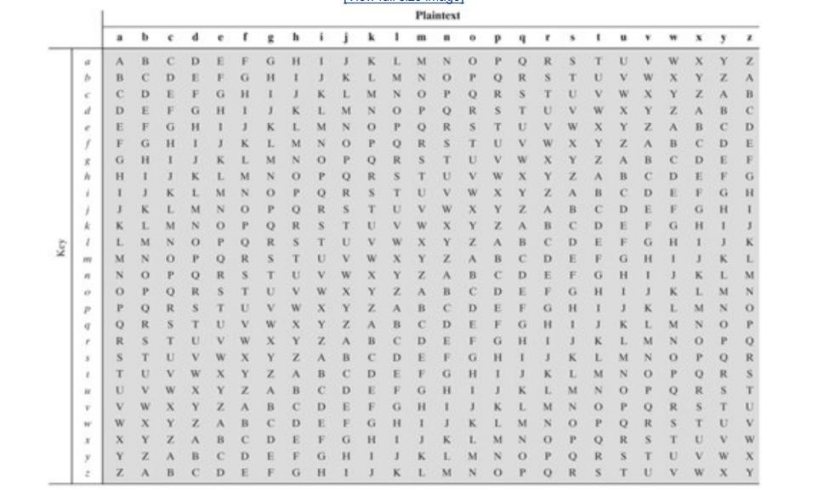

To encrypt a message, a key is needed that is as long as the message. Usually, the key is a repeating keyword. For example, if the keyword is deceptive, the message "we are discovered save yourself" is encrypted as follows:

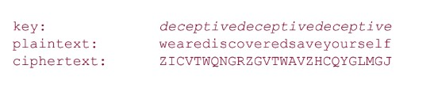

2.Working of Transposition cipher and its variants.

Ans:

All the techniques examined so far involve the substitution of a ciphertext symbol for a plaintext symbol. A very different kind of mapping is achieved by performing some sort of permutation on the plaintext letters. This technique is referred to as a transposition cipher.

The simplest such cipher is the rail fence technique, in which the plaintext is written down as a sequence of diagonals and then read off as a sequence of rows. For example, to encipher the message "meet me after the toga party" with a rail fence of depth 2, we write the following: m e m a t r h t g p r y e t e f e t e o a a t

The encrypted message is

MEMATRHTGPRYETEFETEOAAT

This sort of thing would be trivial to cryptanalyze. A more complex scheme is to write the message in a rectangle, row by row, and read the message off, column by column, but permute the order of the columns. The order of the columns then becomes the key to the algorithm. For example,

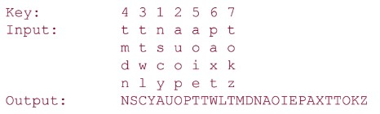

To visualize the result of this double transposition, designate the letters in the original plaintext message by the numbers designating their position. Thus, with 28 letters in the message, the original sequence of letters is:

01 02 03 04 05 06 07 08 09 10 11 12 13 14

15 16 17 18 19 20 21 22 23 24 25 26 27 28

After the first transposition we have

03 10 17 24 04 11 18 25 02 09 16 23 01 08

15 22 05 12 19 26 06 13 20 27 07 14 21 28

which has a somewhat regular structure. But after the second transposition, we have

17 09 05 27 24 16 12 07 10 02 22 20 03 25

15 13 04 23 19 14 11 01 26 21 18 08 06 28

3.What is steganography? Explain. Discuss its advantages and drawbacks.

Ans:

A plaintext message may be hidden in one of two ways. The methods of steganography conceal the existence of the message, whereas the methods of cryptography render the message unintelligible to outsiders by various transformations of the text.

A simple form of steganography, but one that is time-consuming to construct, is one in which an arrangement of words or letters within an apparently innocuous text spells out the real message. For example, the sequence of first letters of each word of the overall message spells out the hidden message.

Advantages:

* The advantage of steganography is that it can be employed by parties who have something to lose should the fact of their secret communication (not necessarily the content) be discovered.
* Encryption flags traffic as important or secret or may identify the sender or receiver as someone with something to hide.

Drawbacks:

* Steganography has a number of drawbacks when compared to encryption. It requires a lot of overhead to hide a relatively few bits of information, although using some scheme like that proposed in the preceding paragraph may make it more effective.
* Also, once the system is discovered, it becomes virtually worthless. This problem, too, can be overcome if the insertion method depends on some sort of key. Alternatively, a message can be first encrypted and then hidden using steganography.

4.What is the difference between block cipher and stream cipher? Ans:

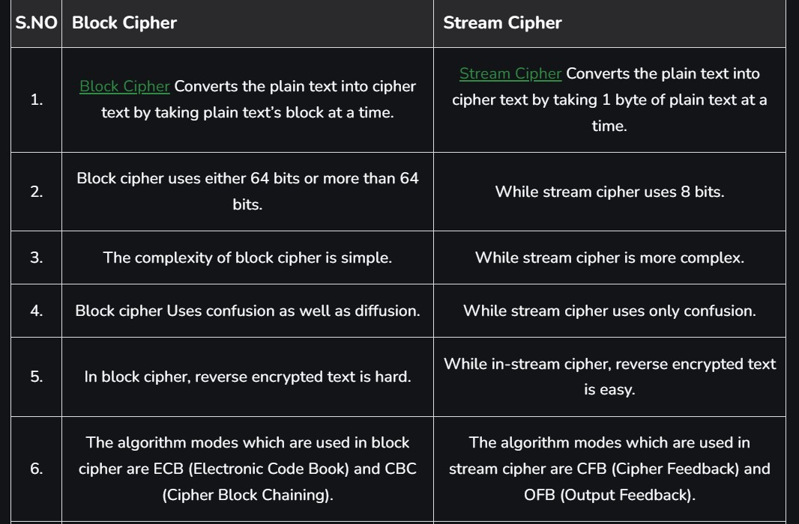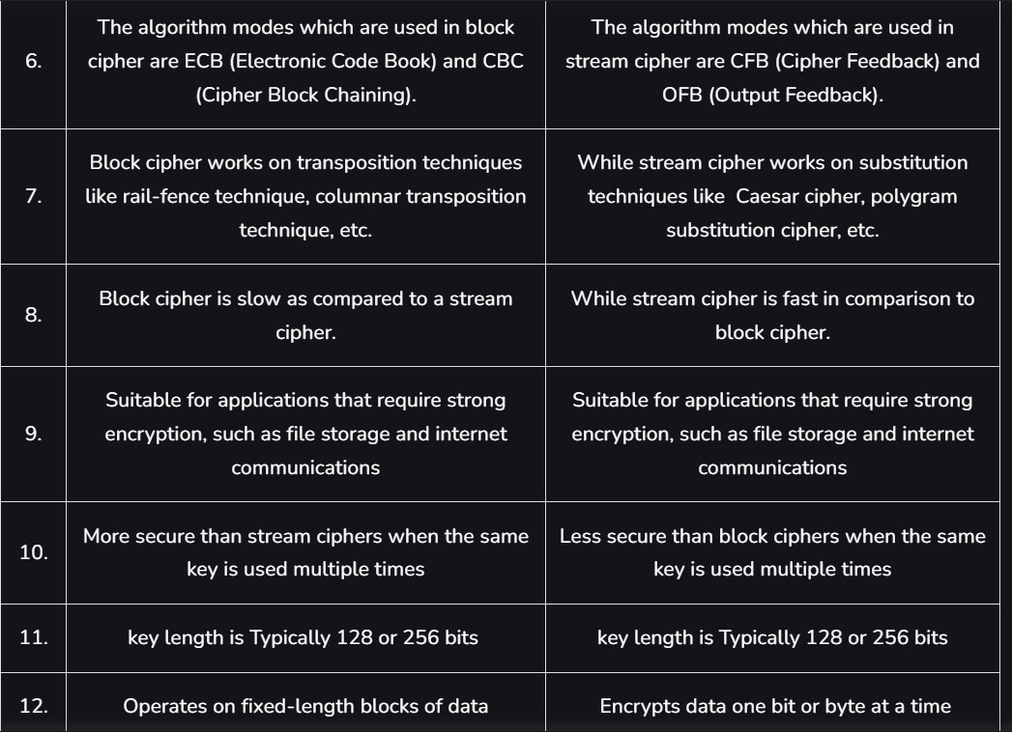

5.Discuss the types of attacks on encrypted messages.

Ans:

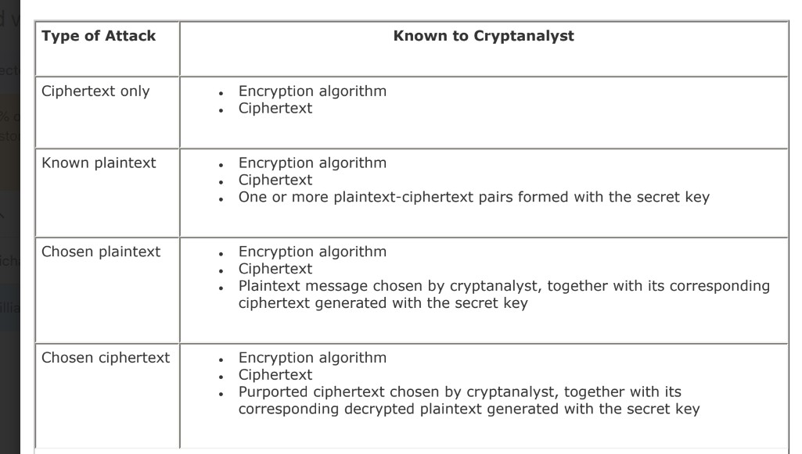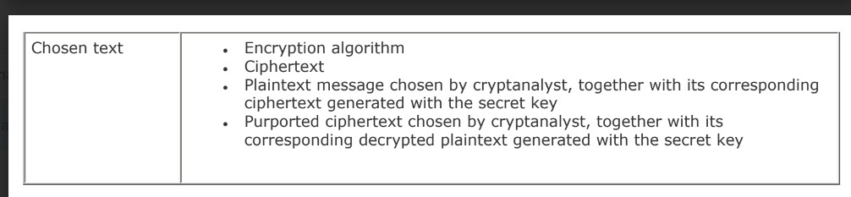

6.Difference between cryptography and cryptanalysis?

Ans: 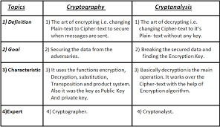

**7.Discuss the strengths of DES?**

**Ans:**

**The Nature of the DES Algorithm:**

Another concern is the possibility that cryptanalysis is possible by exploiting the characteristics of the DES algorithm. The focus of concern has been on the eight substitution tables, or S-boxes, that are used in each iteration. Because the design criteria for these boxes, and indeed for the entire algorithm, were not made public, there is a suspicion that the boxes were constructed in such a way that cryptanalysis is possible for an opponent who knows the weaknesses in the S-boxes. This assertion is tantalizing, and over the years a number of regularities and unexpected behaviors of the S-boxes have been discovered. Despite this, no one has so far succeeded in discovering the supposed fatal weaknesses in the S-boxes.

**Timing Attacks:**

A timing attack is one in which information about the key or the plaintext is obtained by observing how long it takes a given implementation to perform decryptions on various ciphertexts. A timing attack exploits the fact that an encryption or decryption algorithm often takes slightly different amounts of time on different inputs.

**The Use of 56-Bit Keys:**

With a key length of 56 bits, there are 256 possible keys, which is approximately 7.2 x 1016. Thus, on the face of it, a brute-force attack appears impractical. Assuming that, on average, half the key space has to be searched, a single machine performing one DES encryption per microsecond would take more than a thousand years to break the cipher.

It is important to note that there is more to a key-search attack than simply running through all possible keys. Unless known plaintext is provided, the analyst must be able to recognize plaintext as plaintext. If the message is just plain text in English, then the result pops out easily, although the task of recognizing English would have to be automated. If the text message has been compressed before encryption, then recognition is more difficult. And if the message is some more general type of data, such as a numerical file, and this has been compressed, the problem becomes even more difficult to automate. Thus, to supplement the brute-force approach, some degree of knowledge about the expected plaintext is needed, and some means of automatically distinguishing plaintext from garble is also needed. The EFF approach addresses this issue as well and introduces some automated techniques that would be effective in many contexts.

9. Describe DES algorithm in detail.

Or

Explain DES algorithm with the help of block diagram. Ans:

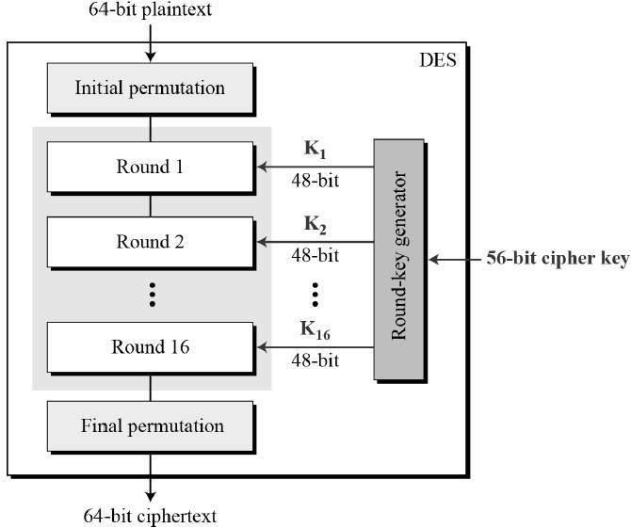

Looking at the left-hand side of the figure, we can see that the processing of the plaintext proceeds in three phases. First, the 64-bit plaintext passes through an initial permutation (IP) that rearranges the bits to produce the permuted input. This is followed by a phase consisting of 16 rounds of the same function, which involves both permutation and substitution functions.The output of the last (sixteenth) round consists of 64 bits that are a function of the input plaintext and the key. The left and right halves of the output are swapped to produce the preoutput. Finally, the preoutput is passed through a permutation (IP1) that is the inverse of the initial permutation function, to produce the 64-bit ciphertext. With the exception of the initial and final permutations, DES has the exact structure of a Feistel cipher.

The right-hand portion of Figure shows the way in which the 56-bit key is used. Initially, the key is passed through a permutation function. Then, for each of the 16 rounds, a subkey (Ki) is produced by the combination of a left circular shift and a permutation. The permutation function is the same for each round, but a different subkey is produced because of the repeated shifts of the key bits.

**10. What are the essential ingredients of a symmetric cipher? what are the 2 basic functions used in encryption algorithm?**

A symmetric encryption scheme has five ingredients (Figure 2.1):

* **Plaintext:** This is the original intelligible message or data that is fed into the algorithm as input.
* **Encryption algorithm:** The encryption algorithm performs various substitutions and transformations on the plaintext.
* **Secret key:** The secret key is also input to the encryption algorithm. The key is a value independent of the plaintext and of the algorithm. The algorithm will produce a different output depending on the specific key being used at the time. The exact substitutions and transformations performed by the algorithm depend on the key.
* **Ciphertext:** This is the scrambled message produced as output. It depends on the plaintext and the secret key. For a given message, two different keys will produce two different ciphertexts. The ciphertext is an apparently random stream of data and, as it stands, is unintelligible.
* **Decryption algorithm:** This is essentially the encryption algorithm run in reverse. It takes the ciphertext and the secret key and produces the original plaintext

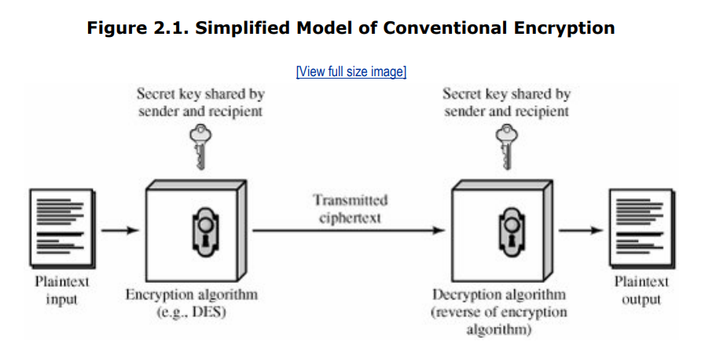 **2 basic functions used in encryption algorithm are**

1. **Substitution**
2. **Transposition**

**8.Discuss the purpose of s-boxes?**

Ans:

The round key Ki is 48 bits. The R input is 32 bits. This R input is first expanded to 48 bits by using a table that defines a permutation plus an expansion that involves duplication of 16 of the R bits. The resulting 48 bits are XORed with Ki . This 48-bit result passes through a substitution function that produces a 32-bit output.

The role of the S-boxes in the function F is illustrated in Figure 3.6. The substitution consists of a set of eight S-boxes, each of which accepts 6 bits as input and produces 4 bits as output.

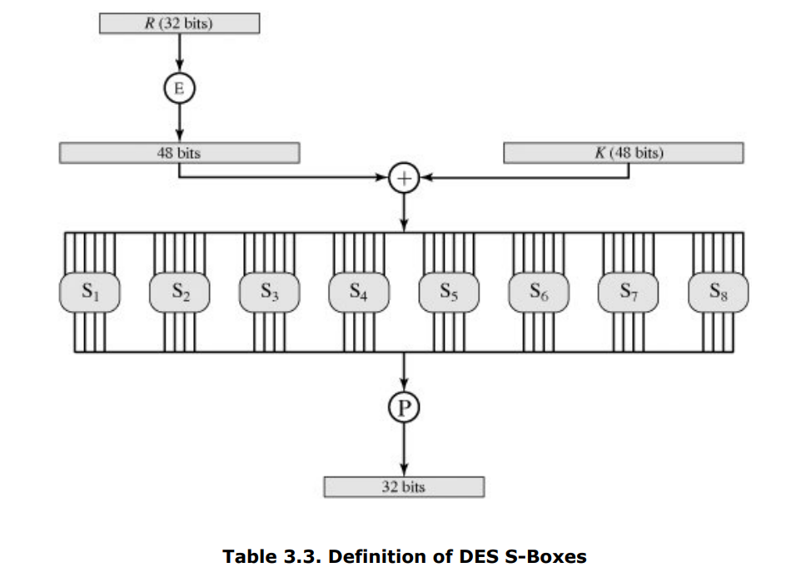

Each row of an S-box defines a general reversible substitution.The operation of the S-boxes is worth further comment. Ignore for the moment the contribution of the key (Ki). If you examine the expansion table, you see that the 32 bits of input are split into groups of 4 bits, and then become groups of 6 bits by taking the outer bits from the two adjacent groups. For example, if part of the input word is

... efgh ijkl mnop …

this becomes

... defghi hijklm lmnopq …

The outer two bits of each group select one of four possible substitutions (one row of an S-box). Then a 4-bit output value is substituted for the particular 4-bit input (the middle four input bits). The 32-bit output from the eight S-boxes is then permuted, so that on the next round the output from each S-box immediately affects as many others as possible.

**Example for Diffie-Hellman key exchange**

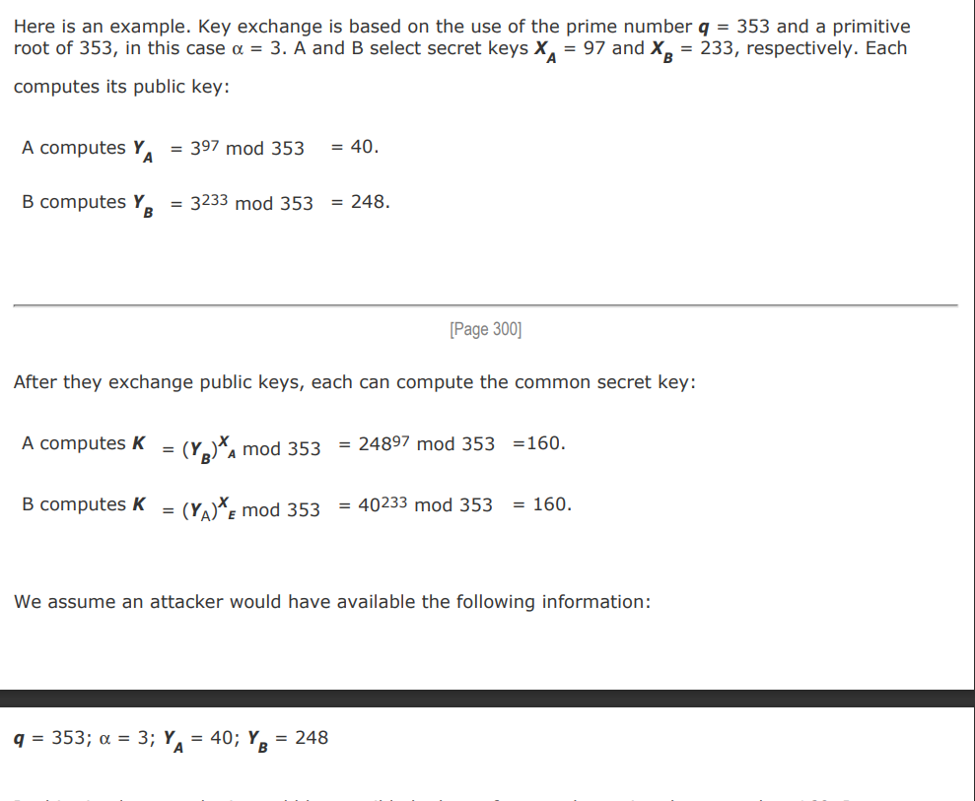

In this simple example, it would be possible by brute force to determine the secret key 160. In particular, an attacker E can determine the common key by discovering a solution to the equation 3a mod 353 = 40 or the equation 3b mod 353 = 248. The brute-force approach is to calculate powers of 3 modulo 353, stopping when the result equals either 40 or 248. The desired answer is reached with the exponent value of 97, which provides 397 mod 353 = 40. With larger numbers, the problem becomes impractical.